Data verwerken:

1. Open TEST….mat file
2. Click Finish
3. data = load('your_data_file_name.mat');
   1. e.g.: data = load('TEST_20243129_1708');
4. Check fields:

disp(fieldnames(data)); % Check the fields at the top level

disp(fieldnames(data.LOG)); % Check the fields inside LOG

disp(fieldnames(data.LOG.Trial)); % Check the fields inside Trial

1. Calculate reaction times:

% Loop through each trial to calculate the reaction times

for i = 1:length(data.LOG.Trial)

% Ensure that both FeedbackOnset and StimPhaseOnset are valid numbers

if isnumeric(data.LOG.Trial(i).FeedbackOnset) && isnumeric(data.LOG.Trial(i).StimPhaseOnset)

% Calculate reaction time

data.LOG.Trial(i).ReactionTime = data.LOG.Trial(i).FeedbackOnset - data.LOG.Trial(i).StimPhaseOnset;

else

% Handle invalid data (e.g., missing or non-numeric values)

data.LOG.Trial(i).ReactionTime = NaN; % NaN indicates a missing or invalid value

end

end

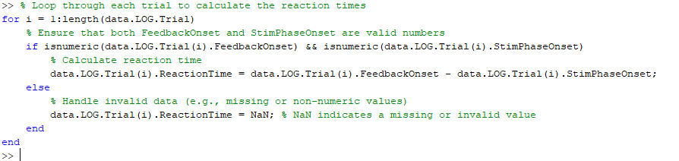

1. % Convert the LOG.Trial structure array into a table

trial_table = struct2table(data.LOG.Trial);

1. Display the table to verify that the reaction times are correct

disp(trial_table);

1. Export to xlsx file (csv file gave inaccurate reaction times)

writetable(trial_table, 'trial_data.xlsx');

% Convert the LOG.Trial structure array into a table

trial_table = struct2table(data.LOG.Trial);

%Display the table to verify that the reaction times are correct

disp(trial_table);

%Export to xlsx file (csv file gave inaccurate reaction times)

writetable(trial_table, 'trial_data.xlsx');